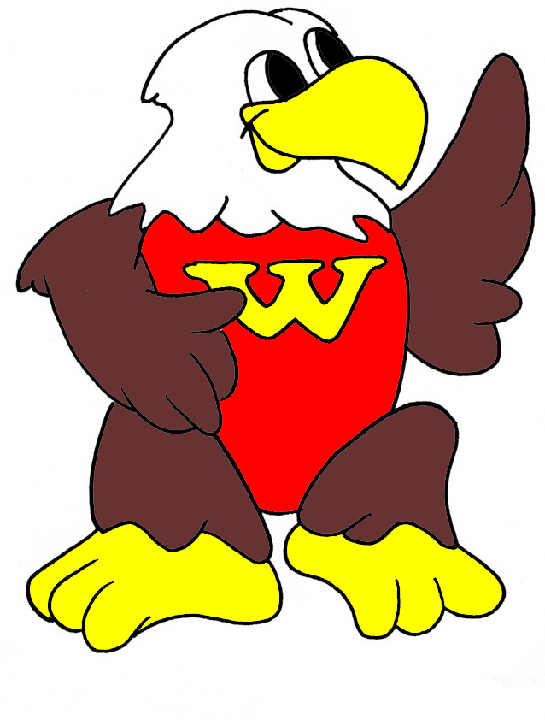
WASHINGTON ELEMENTARY
1401 Washington Street • Wenatchee, WA 98801 p:509.662.5504 f:509.663.0721
www.wenatcheeschools.org/wa

Washington Elementary is a learning community that ensures high levels of learning for each student.

